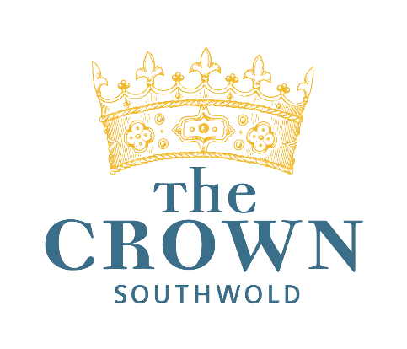
Snacks
(gf/pb) | Pecorino and truffle mixed nuts | 175 | £3.50
(gf/pb) | Marinated olives | 144 | £4.50
 | Harry’s breads, flavoured butter | 298 | £6.00
 | Blythburgh pork and Parmesan cocktail sausage rolls | 225 | £4.00
 | Lane farm Suffolk salami, pickles | 190 | £4.00
(gf) | Marinated anchovies, capers, Aleppo pepper | 210 | £4.00
 | Starters
(v) | Wild garlic soup, seeded sour dough & St.Jude curd bruschetta | 680 | £10.00
(gfa) | Roasted pepper, pancetta & bitter leaf salad, croutons, parmesan, poached Low farm egg | 595 | £11.00
 | New season Cromer crab and prawn arancini, pickled fennel, sea lettuce, bisque sauce | 700 | £13.50
 | Sauteed chicken livers on toasted brioche, green peppercorn, madeira and wild garlic sauce | 750 | £11.00
(pb) | Watermelon, olive & vegan Feta salad, toasted seeds, balsamic glaze | 490 | £11.00
(v) | Grilled goat’s halloumi, herb falafel, preserved lemon, pomegranate, harissa yoghurt | 650 | £12.00
 | Mains
(gf) | Roast Blythburgh pork chop, Pomme Anna, Bramley apple puree, charred Hispi cabbage, crispy nero, Wild Wave cider sauce | 905 | £23.00
(gf) | Poached chicken breast, Chanterelle mushrooms, roast parsley root, wild garlic, Madeira chicken sauce | 850 | £25.00
 | 32 day aged sirloin steak, chunky chips, charred gem, black garlic emulsion, crispy onions, beef butter | 985 | £29.00
(gf) | Roast Skrei cod Fillet, sauteed potatoes, Wangford greens, seaweed & Aleppo pepper butter | 875 | £24.00
(gf) | Pan fried hake fillet, chorizo, onions, roast pepper, chickpeas, potato, capers, wild garlic aioli | 810 | £23.50
(v,gf) | Parmigiana Di Melanzane : Roast aubergine, tomato chilli sauce, smoked English Mozzarella, Parmesan, Fen Farm cultured cream, rocket salad | 810 | £20.00
(pb, gf) | Miso glazed roast cauliflower, sesame seeds, pickled ginger, roast peanuts, Katsu sauce, Kombu rice | 780 | £20.00
(pb) | Beetroot braised pearl barley ’Risotto’, purple sprouting broccoli, mushrooms, wild garlic | 723 | £19.50
(gf) | Adnams Ease Up IPA battered fish and chips, mushy peas, wally, curry sauce, tartare sauce  50p from every fish and chips purchased is donated to support the charitable works of the Adnams Community Trust | 995 | £20.50
 | Sides
(pb,gf) | Chunky chips | 412 | £4.95
(gf) | Truffle oil and Parmesan fries | 516 | £4.95
(v,gf) | Sautéed Maris Peer potatoes | 210 | £4.95
(v,gf) | Wangford greens, garlic butter | 380 | £4.95
(pb,gf) | Braised red cabbage | 205 | £4.95
(pb/gf) | Wangford sprouting broccoli, toasted seeds, lemon oil | 250 | £4.95
 | Pudding
(gf) | Mr Barret’s honey & rhubarb panacotta, rhubarb & hibiscus compote, pomegranate sorbet, toasted almonds | 715 | £9.50
(v) | 70% dark chocolate ganache, blood orange & pistachio tart, pistachio ice cream | 710 | £10.00
(v,gf) | Mr Barrett’s honey & miso crème brulee | 700 | £9.50
(v) | Tiramisu profiteroles, coffee & chocolate caramel, coffee ice cream | 684 | £9.50
(gf) | Citrus meringue, lemon curd, posset truffle, lemon curd ice cream, blood orange | 710 | £9.50
(pb,gf) | Suffolk Meadow ice creams & sorbets (per scoop) | 70/40 | £2.50
 | Selection of British artisan cheeses, crackers, tracklements | 652 | £14.00
 | Petit Fours for tea/coffee
 | Chocolate truffles: White chocolate and Adnams Copper House Gin  Dark chocolate and Adnams Spirit of Broadside | £3.50 per pair

